32 Windsor Gardens
Paddington
London

Dear Prince George

As you know, I am an orphan bear from Peru, living in London with the Browns, my new family.
Peru was not part of your Great Grandmother's family, so imagine how excited I was when your GanGan, the Queen, invited me to tea to celebrate her diamond jubilee. I was so nervous that I spilt the tea and squashed the lovely cake. The Queen didn't mind at all. She was so kind, tolerant, polite to everyone and, most of all, so very wise.
‘Be kind and polite and the world will be alright,’ she said.
I believe that too.
At the tea-party, the Queen told me that she loved marmalade sandwiches and always kept one handy, in case she felt hungry. So do I. Mine is in my hat. The Queen kept hers in her handbag. Isn't that amazing?
She was our GanGan too – thank you for sharing her with us.
We are all so sad that she has gone but happy that she is with your Great Grandfather Philip again.
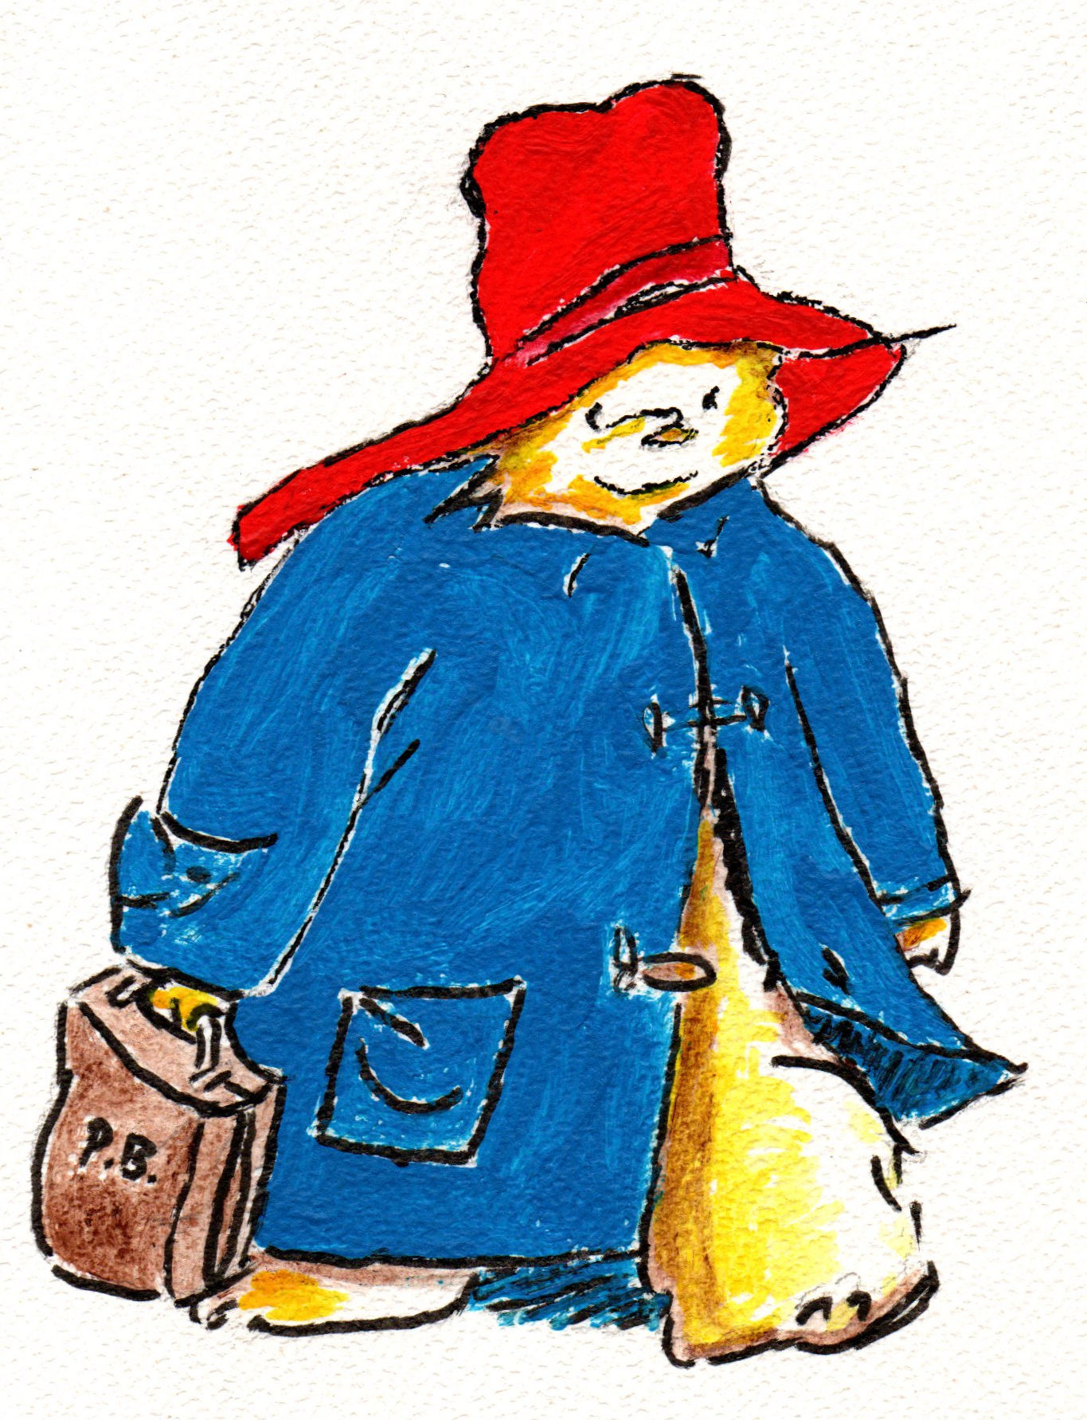Many years from now your GanGan will be there to hold your hand as she shows you the path to follow to be a great King.
I wish you a successful journey your Highness.
Thankyou.
Paddington
PS Sorry about the marmalade stains.

David Gregory
219 words

Painting by Gloria XXXX

