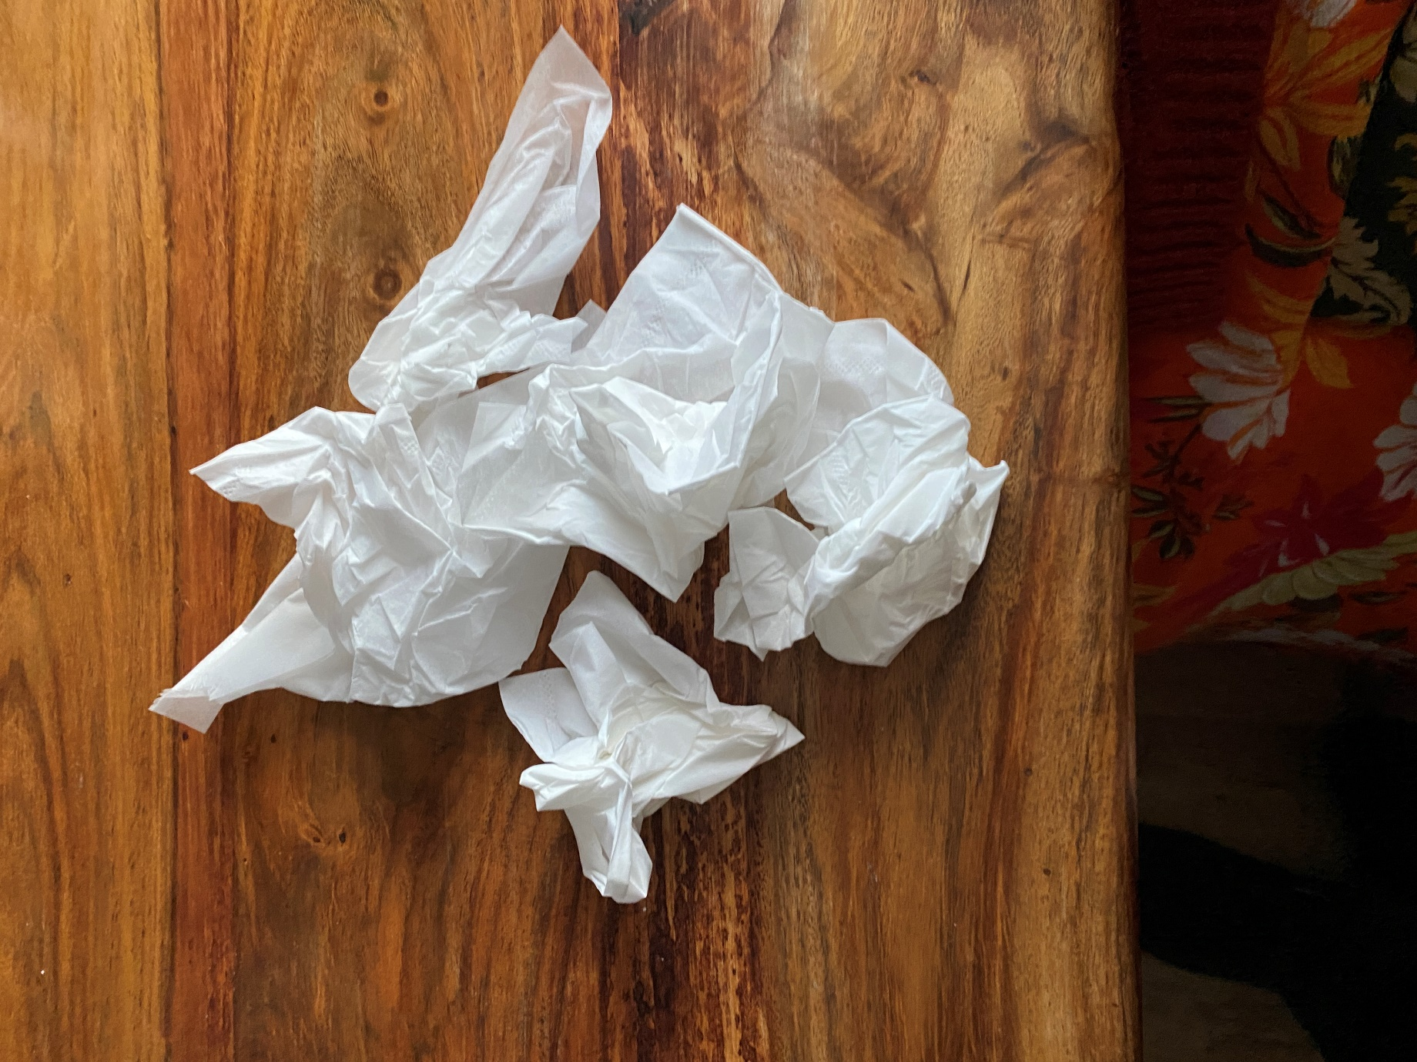
KLEENEX MOMENTS

What was your first and enduring experience of loss? For me it was the tragic passing of a child announced in graphic detail during secondary school assembly.
On the 8th September, Queen Elizabeth II passed away peacefully at Balmoral. Watching television alone, the black suited broadcaster’s solemnity prompted an instantaneous ‘Oh no’ reaction. Tears came into my eyes, a tissue sought, but why? She was a mother but not mine.
The following time of mourning up to the funeral on 19 September made for addictive, sometimes intensely irritating, viewing. Anecdotes shared, ancient rituals explained, trite repetitive emotion- probing questions asked, flower mountains laid, blooms thrown at the passing hearse, spontaneous clapping and renditions of the National Anthem, 2022 revision, mobile phones lighting up the darkness. Walk-abouts – a woman audaciously kissing the new monarch, as yet uncrowned. Vigils in Westminster Hall – heads bowed, ‘commoners’, military and royalty alike. Corgis mournful. Pall bearers in practised flawless symmetry.
Death is the ultimate leveller. Monied, privileged indeed, our incomparable Queen had once stood within touching distance of me in Aylesbury Market Square. Armed marksmen on the roof of Lloyds Bank. Life on parade. Heavy is the head that wears the crown – would you?

Jean Stevens (200 words)

