Last Respects
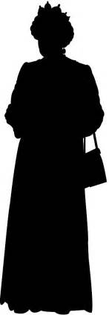
Respect is gained by showing your true worth;
It’s not an asset simply handed down.
You don’t inherit it by right of birth
Like mother’s wedding ring - or father’s crown.

I’ve always thought the system makes no sense
It’s anti-democratic and unfair.
One family living high at our expense
If they expect allegiance, then I’ll swear.

But Elizabeth, when she assumed the throne,
Did not presume that she would be revered.
The queen, the only one I’d ever known,
Took care to show restraint for all those years.

I’d always thought it shouldn’t be allowed
But, feeling something I did not expect,
I went down to the river with the crowds
And stood in line to pay my last respects.

Kevin Cheeseman
121 words

