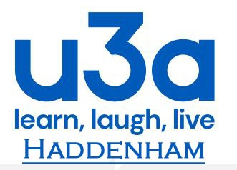 Member Code of Conduct
The Member Code of Conduct clarifies the acceptable standard of behaviour.
u3a members are expected to conduct themselves within the movements “guiding principles”.
Members are expected to:
- know, follow and promote the principles of the u3a Movement at every opportunity.

- always act in the best interests of Haddenham u3a and the u3a Movement, strive to uphold its reputation and never do anything which could bring Haddenham u3a or the u3a Movement into disrepute or expose it to undue risk.

- use Haddenham u3a’s resources responsibly and only to further its stated charitable objects/purposes.

- reflect the current organisational policy of Haddenham u3a, regardless of whether it conflicts with their personal views.

- abide by Haddenham u3a’s procedures and practices.

- treat each other with dignity and respect at all times.

