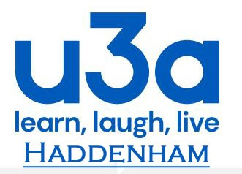 Principles of the u3a Movement

The u3a Movement is non-religious and non-political and has three main principles:

- The Third Age Principle
- Membership of a u3a is open to all in their third age, which is defined not by a particular age but by a period in life in which full-time employment has ceased.

- Members promote the values of lifelong learning and the positive attributes of belonging to a u3a.

- Members should do all they can to ensure that people wanting to join a u3a can do so.

- The Self-help Learning Principle
- Members form interest groups covering as wide a range of topics and activities as they desire; by the members, for the members.

- No qualifications are sought or offered. Participation is for its own sake, with enjoyment being the prime motive, not qualifications or awards.

- There is no distinction between the learners and the teachers; they are all u3a members.

- The Mutual Aid Principle
  - Each u3a is a mutual aid organisation, operationally independent but a member of The Third Age Trust, which requires adherence to the guiding principles of the u3a movement.

  - No payments are made to members for services rendered to any u3a.

  - Each u3a is self-funded with membership subscriptions and costs kept as low as possible.

  - Outside financial assistance should only be sought if it does not imperil the integrity of the u3a movement.

