|  |
| --- |
| Inside this issue |
| Normandy Trip The Pegasus Bridge - one of the sights visited   |
| Cycling Trip   Read about an enjoyable cycling holiday.  Moselle cycle photo 1.jpg |
| Technical Support volunteers needed. |

# General Meetings

## An Actor’s life for me.

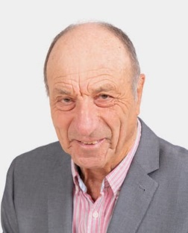The speaker at the July meeting was Jeff Rozelaar who spoke of his life as an amateur actor, teacher, writer and producer.

He described his reluctance as a young person to tread the boards, helping instead backstage at amateur productions until a chance encounter with the great Peter Hall and then gentle persuasion from a teaching colleague got him in to a production of Gilbert and Sullivan’s Patience as a guardsman and he was hooked to the pleasure and excitement of performing before an audience. But ‘an actor’s life for me’ was a risky profession and he quoted the well-known joke, ‘what is the difference between a large pizza and an actor?’ Answer: a pizza can feed a family of four! So he channelled his love of acting in to his teaching and amateur dramatics and for many years performed in and directed productions for schools and local amateur societies.

Jeff went on to reflect on the qualities an actor needs. Good looks help but if you don’t have them make best use of the ‘defects’, as Norman Wisdom did for example, or the ‘fat kid’ James Corden. Conviction, your audience has to be convinced by the character. Voice, be authentic, especially with accents. Character, get in to a character (method acting!) or as Olivier told Dustin Hoffman ’why don’t you just act!’’

Although a successful amateur for many years Jeff became professional aged 75 when he took on work as a film extra and also performed as a one man show in his own play about Disraeli. He ended his presentation using a few props to show the types of characters he has played: Professor Higgins, as the insufferable man, Renee (French accent) in Allo Allo, the insane man in Fawlty Towers, Petruchio (macho man) in The Taming of the Shrew , an insufferable alderman in J B Priestley’s When We Were Married. Finally an American GI in South Pacific ‘we ain’t got dames’. All proving his talent and versatility, amateur or otherwise, in providing us with a very entertaining talk.

## The White Mouse

Our speaker Paul Barwick gave a very interesting talk about Nancy Wake, The White Mouse. Who was this extraordinary spy, nicknamed by the Gestapo The White Mouse with a five million franc price on her head? Nancy Wake is a name that is not as well-known as many other spies and resistance fighters of the Second world war, but a film was made of her work and it is believed that Sabastian Faulkes, novel ‘Charlotte Gray’ was inspired by her story.

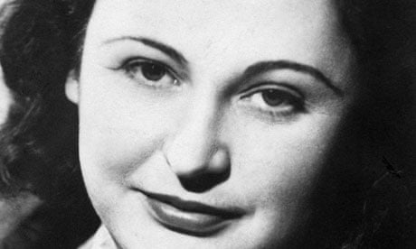Paul described Nancy as a formidable, fearless and brave fighting force who had an uncanny ability to run rings around the Gestapo in occupied France, belying her nickname The White Mouse. She was born in New Zealand in 1912, the youngest of five children, and raised in Australia, mainly by her mother.

A small inheritance when she was sixteen allowed her to move to London where she studied journalism. She worked as a journalist in Paris, met and married the wealthy industrialist Fiocca with whom she moved to Marseilles, where they lived in a grand style. In June 1940 the Nazis occupied France. In her pre-war work as a European correspondent Nancy had witnessed the rise of Hitler and the brutality of the Nazi regime and she knew she had to fight back. Nancy became part of the escape route in Southern France for Allied personnel evading capture, driving an ambulance converted to hold escapees. She was high on the wanted list of the Gestapo, but she fled to Britain after her husband was killed by them when he refused to betray her.

She was recruited by the Special Operations Executive (SOE) and trained for guerrilla warfare in France. In 1944 she parachuted into the Auvergne region to co-ordinate a large resistance force which carried out many successful attacks and her own exploits were legendary. After the war she was honoured by the Allies and the French with the George medal, The US medal of Freedom, the Croix de Guerre and the Legion d ‘Honneur. Nancy found life in peacetime was difficult to adjust to and made several attempts to settle back in her home country, Australia, tried to get elected to the Australian Parliament but felt unrecognised and unappreciated and refused the decorations offered.

After the death of her second husband, a former English pilot, in 1997, she finally settled in London and in 2004 accepted the Companion of Order of Australia and lived to the ripe old age of 98.

Thanks to Paul for a riveting account of this amazing woman whose story deserves to be told.

## Jenner and Vaccinations

Steve Bacon, a researcher and television presenter of the history of medicine, presented the argument for Edward Jenner being known as the ‘father of immunology’ and the pioneer of the concept of vaccination in helping to tackle the prevalent disease of smallpox.

In Jenner’s time, the eighteenth century, smallpox killed around 10% of global population with the number as high as 20% in towns and cities where the disease spread easily. It was not always fatal but left sufferers disfigured and often blind. It was also known that there was a link with cowpox , that milkmaids who contracted cowpox and recovered seemed to have an immunity to smallpox.

Lady Mary Wortley Montague , wife of the English Ambassador to Turkey, in the early 18th Century had lost her looks to smallpox but saw that the disease was treated in Turkey by a small amount of the pox being put in to the blood by a small scratch on the arm from which the patient recovered quite quickly and had lifelong immunity. She decided to test this by having her son inoculated. So convinced was she of the efficacy of this treatment that on returning to England she worked hard to get it accepted among her friends in the Royal Court, including the then Princess of Wales. In 1721 an experiment was done on condemned prisoners who were promised freedom if they survived and many of them did! The problem however was that it was an expensive treatment because isolation of patients was required and so it did not become a universal treatment. However, this was the Century of Enlightenment and science was flourishing.

Edward Jenner, born in 1749, an English physician and scientist, working in a small Gloucestershire town, knew of the link between cowpox and smallpox and that inoculation (vaccination comes from the French word for cow) worked but became determined that the treatment should be recognised and adopted widely. He set about testing the hypothesis by doing many experiments, writing up the method and the results and made immunology more widely understood.

He presented his work to the Royal Society and after much lengthy deliberation his findings were accepted. Jenner was appointed physician to George IV and given a pension. He did not live to see his work become the foundation for the Public Health Act in 1853 when it was compulsory for children over the age of 4 months to be vaccinated, though in 1898 conscientious objection to the vaccination was allowed.

Child vaccination for smallpox was continued to be promoted worldwide right through until the latter half of the twentieth century when the World Health Organisation declared that smallpox had been eradicated. Jenner became known as ‘the father of immunology’ because he proved the science of the treatment and got it accepted by the Scientific Establishment.

In science credit goes to the man who proves the theory, not the man to whom the idea occurs.

## Organised Crime, Policing and Intelligence

Richard List retired from Thames Valley Police in 2021 as a Detective Chief Superintendent after thirty years’ service. Richard started by giving us a historical perspective on the three aspects of his talk.

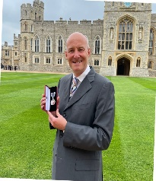We heard about the origins of policing, going back to Edward 1st who created a policing system, one of the aims being to combat highway robbery. His Statute of Winchester allowed him to cut the trees back along the highways which successfully reduced the incidence of highway robbery. Policing as we know it today started in 1829 with the Metropolitan Police in London spreading nationwide in 1856.

Intelligence gathering has been used through history, going back to biblical times, with God telling Moses to send spies to explore the land of Canaan. San Tzu the 4/5th century Chinese military strategist used it to great effect as described in his book The Art of War, as did Sir Francis Walsingham, the spymaster of Elizabeth 1st whose loyalty and proficiency in international affairs and espionage were essential to Elizabethan government, with his successful impeding of Catholic plots against the queen and sabotaging of Spanish invasion attempts.

Organised crime, now a multi-billion-pound global problem, was first identified in 17th century Germany and the Netherlands, declining as states became stronger. In the UK we saw an example in the Gunpowder Plot. The weak Bourbon dynasty in Italy in the 19th century led to the formation of the Mafia, driven by the rise of Italian Fascism to Sicily and the US in the 1920s.

Driven by money and globalisation organised crime is supercharged by technology and the dark web which is used by criminals, including paedophiles, to buy drugs and weapons and exchange information. Global inequality has enabled organised crime lords to invest in poor countries with weak governments. Take Ecuador as an example. After WW2 Enver Hocha took power in Albania which became a deeply closed communist state. After his death this fell apart and organised crime flourished, with the Albanians taking over in Ecuador, Guayaquil is now the main shipping port of drugs to Europe.

Although the UK has relatively less organised crime than other countries it is still worth in the region of 50 billion to criminals. To tackle the problem of organised crime, in 2000 the UN held the UN Transnational Organised Crime Convention. The first Organised Crime Strategy was implemented in Scotland followed by the other UK nations. The focus is on being proactive rather than reactive, with four components: **Pursue** - prosecuting and disrupting people engaged in serious and organised crime: **Prevent** - preventing people from engaging in this activity: **Protect** - increasing protection against serious and organised crime: **Prepare** - reduce the impact of this criminality where it takes place.

Richard explained the many problems of tackling organised crime. The criminals are serious, experienced and well resourced with professional enablers such as solicitors and accountants. They are powerful, intimidating, willing to corrupt and use high levels of violence. They understand police tactics and limitations and are unhindered by bureaucracy and regulations. He went on to explain the importance of gathering incontrovertible evidence to prosecute organised crime gangs using methods of covert intelligence gathering such as.; paid informants, telephone tapping (which in the UK requires a warrant from the Home Secretary and can’t be used in evidence but can provide key information), surveillance and undercover officers. Two key pieces of legislation cover covert intelligence gathering, the Regulation of Investigatory Powers Act 2000 and the Human Rights Act 1998.

Richard told us of a successful operation involving EncroChat, a Europe-based communications network and service provider that offered modified smartphones allowing encrypted communication, used primarily by organised crime members to plan criminal activities. Police infiltrated the network during a Europe-wide investigation, resulting in an announcement by an unidentified source associated with EncroChat that the company, which had around 60,000 subscribers, would cease operations because of the police investigation. The investigation led to at least 1,000 arrests across Europe as of 22 December 2020.

A fascinating insight into this global problem and the work of our police in tackling it!

Technical Support volunteers needed.

We are looking for volunteers to join our technical team providing support at our General Meetings. Duties will include setting up the sound system, laptop and projector, and running the ‘Speakers PowerPoint Presentation’ where necessary.

Training will be provided and there will always be someone to give assistance should it be necessary. If you would like to join our technical team please contact Sally Lajalati on 07872 640 934 or email sallylansten@gmail.com

## **Tuesday 12th December 2023**

**ELLESBOROUGH SILVER BAND & CHRISTMAS REFRESHMENTS**

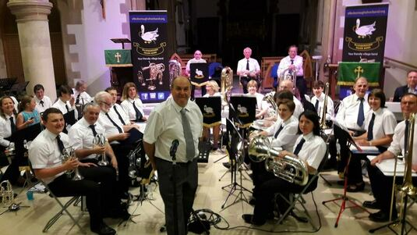

A return visit from the popular Ellesborough Silver Band who will definitely get us into the Christmas spirit.

Founded in 1896, the band has a colourful history playing to audiences (including royalty!) at home and abroad. Over the years the band has played prestigious venues such as Chequers and the Albert Hall.

The band was first led by Ellesborough man George Birch. The band was only disbanded during the two world wars.

During Neville Chamberlain’s reign as Prime Minister, the band was invited to Chequers to play Christmas Carols. In 1992, the band played in front of Prince Charles and Princess Margaret at the Guttmann Centre in Aylesbury.

The band has undertaken tours to Germany and France, and had a string of successes in the early 1990s when they won several awards, including getting to the National Brass Band Finals at the Albert Hall twice.

# Diary Dates

## Future General Meetings

### 2:15 for 2:30

## **Tuesday 9thJanuary 2024**

## **Speaker:** Ann Ford

**MORRIS MINORS IN THE MEDIA**

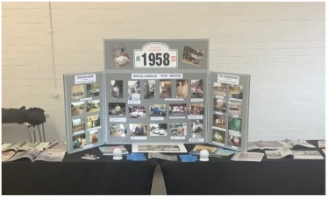An informative but light-hearted and often amusing presentation by Ann Ford, ably assisted by her husband John who ran a successful business hiring out their collection of Morris Minors (and some other classic cars) to film, TV and publishing companies spanning a period of 25 years. Her presentation, supported with a comprehensive photographic display and other memorabilia, includes personal recollections of major films and TV sitcoms.  The cars were frequently used as ‘props’ in magazine advertising.  Eventually, they diversified to weddings, and some of them were very unusual indeed. They sometimes transported VIPs such as Members of Parliament and pop stars to charity events. As this is a ‘retro’ subject, Ann even dresses to match the period! Questions and audience participation to view the display is encouraged at the end of the presentation.

## Tuesday 13th February 2024

## Speaker: Catherine Jones

**From Guns and Roses to Hearts and Flowers**

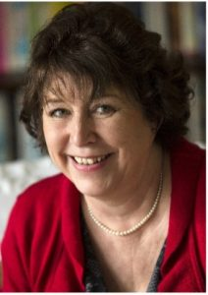Catherine Jones has a contrasting career having joined the army straight from an all-girls school and moved to become an international best-selling author.

She joined the army in 1975 and served until she became pregnant in 1984. Catherine tells just how difficult it was for a woman to be recognised as an officer in a male dominated environment. Then, in a brief moment of boredom during the 5 years when she produced 3 children and moved house 6 times, Catherine wrote her first book. Since then she has carried on with writing books but given up getting pregnant and moving house. She has lived in Thame for nearly 30 years and has now written 2 non-fiction books and 21 published novels.

## Tuesday 12th March 2024

## Speaker: Dr Kathryn Harkup

**Superspy Science: Science, Death and Tech in the World of James Bond**

The adventures of James Bond have thrilled and delighted readers since Ian Fleming’s novel Casino Royale was published in 1953, and when the movie of Dr No was released in 1962 Bond quickly became the world’s favourite secret agent.

Science and technology have always been central to the plots that make up the world of Bond, and in Superspy Science Kathryn explores the full range of 007’s exploits and the arms, technologies, tactics and downfalls of his various foes., from the practicalities of building a volcano-based lair, to whether being covered in gold paint really will kill you. If your plan is to take over the world, whether it is better to use bacteria, bombs, or poison. Kathryn brings us the answers.

Could our favourite Bond villains actually achieve world domination? Were the huge variety of weapons and technology in Bond’s arsenal ever actually developed? And would 007 actually escape all those close shaves intact? From the plots to the gadgets to the ludicrous ways that his life is threatened, this talk takes an in-depth look at the scientific world of James Bond.

# News from the groups

### Music Appreciation

Music Appreciation Group 1 meets on the first Monday of the month. We choose programmes of music for the group to listen to and then to comment on and we are grateful for contributions from all members of the group. We hopefully end up with a greater understanding of the range of composers and instruments and their music. The concentration is on what might be loosely called classical music rather than pop. Currently we have room in the group for one or two new members. So, if you are interested in joining, please give the group leader Ed Bullimore a call on 01844 291011 or e mail on edbten@yahoo.co.uk

### Discussion Group 1

The first Discussion Group, founded in the early days of Haddenham U3A, has prospered and survived various vicissitudes. The group met in Christine Patterson’s house for many years until her sad death. Then the group became peripatetic for a while. Next, we enjoyed the long-standing and generous hospitality of Tricia and Richard Hirst. Now we are well bestowed in the Rosary Room attached to the Church of The Good Shepherd, which provides both kitchen and toilet for a modest subscription of £2 each per meeting.

We meet on a Monday morning in the third week of the month. Membership is now stabilised at eight which we find is the optimum size for our deliberations. Our meetings last for two hours with a short break for refreshments. Each member presents an issue for discussion. Recent topics have included the fate of HS2, the efficacy of the 20mph limit and the morality or otherwise of the triple lock. Our discussions are lively, reasoned, and respectful, so although, of course, we carry our ICE card with us, we hope it will not be necessary during our debates!

Peter Wenham

### Table Tennis

We are very inclusive and welcome all ages and abilities.

A little tuition can be available, and the emphasis is on having fun- with lots of Play for as long or short a time as you feel comfortable with within the 2-hour session.

However, if you are super fit and competitive you will find soulmates too.

Come and give us a try.

### Square Dancing

The Square Daning Group is looking to recruit new members (including men) No previous dance experience is needed but a sense of humour and a desire to have fun is an essential. This is a great way to exercise and make friends.

The group meets on a Thursday at 12:00 until 1:30 in Haddenham Village Hall, using the entrance opposite the library. The cost is between £3 & £5.

Please contact Marion Hadded marionfchadded@gmail.com

### Friday Lunch Group

Great news for the Friday Lunch Group, Linda Axford has taken over the running of the group. The first outing is to The Dinton Hermit, which is full at the moment. Look out for the sign up sheets at the General Meetings.

### Sunday Lunch Group

A party of 23 people enjoyed a delicious and convivial meal at The Peacock on October 22nd. This is the final one I organised having stepped down as leader.

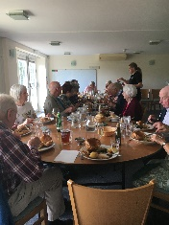It is a thriving group but unfortunately no one else has come forward to take over as leader so, at the present time, it has ceased to function.

If you, or a small “committee”’ of people, would like to find out more about running the group then please speak to Doreen Barker or me or any one of the u3a committee.

It would be such a shame for it to stop indefinitely having been so successful for many years.

Annette Marsden

### Walking Group

The Longer Distance Walking Group have found a new project! Shakespeare’s Way is a 140 mile footpath from Stratford to London's Globe Theatre which he might have walked if he'd had spare time when not writing 39 plays and 159 sonnets! Several new members were welcomed to our first ten mile section, much of which was in the delightful grounds of Ditchley Park (stags were hunted in Shakespeare’s time) and Blenheim Palace. Further full day monthly walks will take us through Oxford, Marlow and into London on The Thames Path.

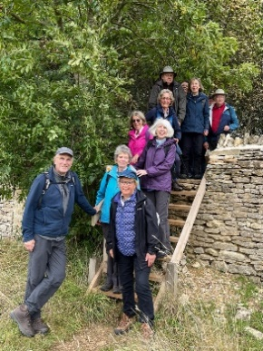



|  |  |
| --- | --- |
|  |  |

# Trips

## Trip to the D-Day landing grounds

By any measure, the scope of the 4-day trip to Normandy for 40 people was ambitious for a u3a group. However, our comfortable ferry trip from Portsmouth couldn’t compare in any way with the vast complexity and sacrifice of landing 156,000 troops nearly 80 years ago. Nonetheless, our guide, u3a member Mike Phillips, managed to pull it off in fine style.

After an amusing incident when the Caen port shuttle bus grounded on the ferry’s ramp, we arrived in our own coach at our hotel on Bayeaux’s ring road, which was originally constructed by the Allied Forces to enable military vehicles to avoid the narrow streets of the beautiful old city. After a good night’s sleep, we drove to nearby Arromanches to view the only remains of the artificial “Mulberry Harbour’s”, on Gold Beach, where the British and Canadian troops landed. These impressive concrete pontoon structures were towed across the Channel and flooded to settle on the shallow seabed, to protect supply ships supporting the invasion.

Over three days we visited the site of disastrous slaughter of US troops at Omaha Beach on 6th June, 1944, and the more successful Utah Beach, where there were only 14 US casualties, as well as the places that have acquired almost mythical status through propaganda and feature films. These included A stone building with a clock tower
Graignes, where 80 surviving US paratroopers holed up after being mistakenly dropped in flooded marshland, and Sainte-Mère-Eglise, where Pfc John Steele famously landed and hung by his parachute from the church tower.

We also visited the American, German and British Cemeteries. The American Cemetery features over 9,000 individually inscribed marble crosses in immaculately tended grounds, whereas the austere German Cemetery marks 21,000 dead with unnamed tablets and a 20-foot high tumulus of unidentified remains, all set in a park of 1200 sponsored maple trees.

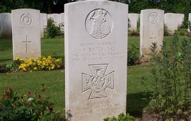The British War Cemetery at Bayeaux takes the middle road, with elements of an English garden and four conker trees that are said to be a not-so-subtle reference to the Latin inscription at the entrance, which translates as “We, once conquered by William, have now set free the conqueror's native land. Here, among the graves of 5,500 British soldiers, lies Corporal Sidney Bates VC, “a true Camberwell boy.

To lighten things up, many members took the opportunity to visit the Bayeaux Tapestry and the town’s beautiful cathedral, as well as making the most of the local cuisine and fine wine. The less said about the region’s infamous Calvados, the better!

We also paid our respects at the recently completed British Normandy Memorial at Ver-sur-Mer, overlooking Gold Beach. This serene and moving site commemorates by name each of the 22,442 servicemen and women under British command who fell on D-Day and during the Battle of Normandy.

To complete our understanding of this incredible invasion plan, our final day included a detailed presentation at the Pegasus Bridge Museum at Bénouville. The museum grounds contain the original bridge and mark the night landings of 180 men of the Ox & Bucks Light Infantry in gliders, three of which landed within yards of this strategic crossing on the Caen Canal, to see the first action of D-Day just after midnight on 6th June. Pegasus Bridge has a special significance for Haddenham, as the Glider Pilot Regiment trained here. The taking of the bridge enabled Allied troops to move quickly inland from Sword Beach, eventually meeting up with US armoured divisions circling south from the Cherbourg peninsula, and ultimately across the river Seine to liberate Paris on 19th August 1

No historical accounts or feature films could substitute for actually visiting the terrain and strategic locations of Normandy in the company of an expert guide. Michael put the whole intricate and costly campaign in context for us, presenting a truly balanced view of the price paid by both sides in terms of successes, failures, misjudgements and, most of all, young lives.

**The group thanks Michael and Sally Phillips for organising the trip.**

## Cycling Group Holiday September 2023

The Cycling Group holiday to the Moselle in September was one of our most successful and beautiful trips. We started in Saarbourg near the Luxemburg border, a delightful, busy town with a castle perched above the river, half-timbered buildings decorated with colourful geraniums, and a waterfall flowing through its centre. We spent a morning exploring before joining our river boat on the Saar ready to pedal off the next day. The cycle paths in Germany are wide, well marked, well maintained and largely traffic free, and this one had the advantage of being mostly flat and following the winding Saar and Moselle rivers through steep sided vine clad valleys to Koblenz.

As well as pretty towns and villages we were also surprised to find much evidence of Roman life in the area especially in and around Trier which was at one time the largest Roman town north of Rome and which had a most impressive gate, the Porta Negra. The Romans were also responsible for establishing the wine industry in the region and had even left a wine press for us to see. Of course we felt obliged to sample a good deal of the local produce during the week and were favourably impressed! The pretty towns and villages with their painted houses, fountains, cafes, churches with striking modern glass windows and castles with panoramic river views are too many to name, but after Trier one of the highlights was Burg Eltz. We reached this fairy tale castle on foot climbing up through the woods, with a rushing stream below. Throughout its colourful history it has been home to the same family since the 12th century and has never been destroyed.

We all had such a good time plans are already afoot for our next adventure in 2024.

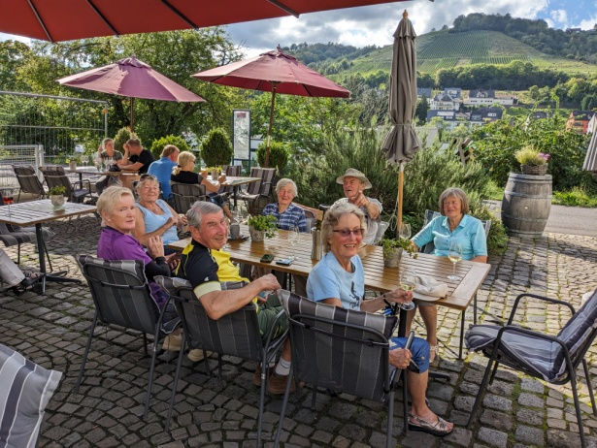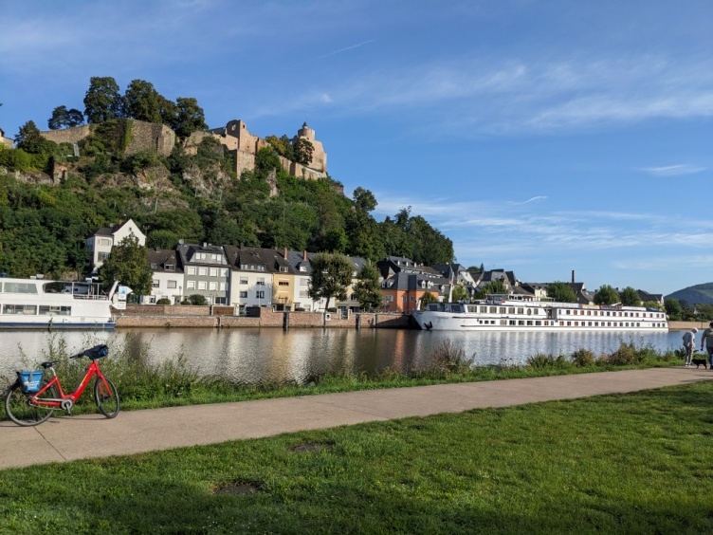

# Upcoming Trips

## u3aCycling Group Holiday

**7 – 14 September 2024**

* **Bike/Barge Baltic Coast**

**Berlin to Stralsund**

**Online details can be found at**

**Berlin to the Baltic Sea Boat and Bike Tour/freedom tours**

**Twin cabins are still available, but there are NO singles available. Any singles joining us will have to double up, if they can find a suitable partner.**

**Prices Twin Cabin Main Deck £1342.00 per person**

**Electric Bike Hire £201**

**Hybrid Bike Hire £91**

**If you are interested, please contact Edgar Skipsey on 07772095218**

**Or edgarskipsey@gmail.com**



