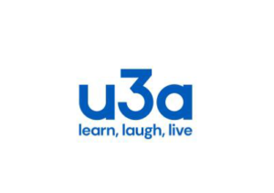
Haddenham U3A Standing Order Form

TO:
BANK: _______________________________________________________

BRANCH: _____________________________________________________

First Payment: please pay the sum of £16.00 immediately
Subsequent Payments: £16.00 on 6th April 2025 and annually thereafter until further notice to
CAF Bank, 40 – 52 – 40, for the account of HADDENHAM U3A, A/C 00021010
Please debit my/our account:
Sort Code: _____________________________
A/C No: _______________________________

Signed: ___________________________________

Date: _____________________________________

PLEASE SEND THIS FORM DIRECTLY TO YOUR BANK (or set it up online).

Please do not send this form to the U3A Membership Secretary.

